Programming Exercise 3
Program Description
This program allows the user to enter a list of their monthly expenses. The user enters the type of expense and the amount for each expense. The program uses the reduce() method to calculate the total monthly expenses and determine which expense has the highest and lowest amounts. The program then displays the total expense, the highest expense, and the lowest expense along with their expense types.

Function 1: main()
Description
The main() function controls the entire program. It collects the user's monthly expenses, stores them in a list, uses the reduce() function to analyze the expenses, and displays the results.
Parameters
None.
Variables
- expenses – A list that stores each expense type and amount.
- expense_type – Stores the type/name of the expense entered by the user.
- amount – Stores the dollar amount of the expense.
- total – Stores the total of all monthly expenses.
- highest – Stores the expense with the highest amount.
- lowest – Stores the expense with the lowest amount.
Logical Steps
- Create an empty list to store expenses.
- Display the program title.
- Ask the user to enter an expense type.
- Check if the user entered "done".
- If the user enters "done", stop asking for expenses.
- If the user enters an expense type, ask for the amount.
- Add the expense type and amount to the expense list.
- Repeat the process until the user enters "done".
- Check if any expenses were entered.
- Use reduce() to calculate the total expenses.
- Use reduce() to find the highest expense.
- Use reduce() to find the lowest expense.
- Display the total expense.
- Display the type and amount of the highest expense.
- Display the type and amount of the lowest expense.
Return Value
None. The main() function displays the results to the user.
Use of reduce()
The program uses the Python reduce() function from the functools module.
Total Expense
The first reduce() operation adds all of the expense amounts together to calculate the total monthly expense.
Highest Expense
The second reduce() operation compares each expense and keeps the expense with the highest amount.
Lowest Expense
The third reduce() operation compares each expense and keeps the expense with the lowest amount.

Program Input
The user enters:
- The type of each monthly expense.
- The dollar amount of each monthly expense.
- "done" when they have finished entering expenses.
Example:
Rent — $1200
Food — $400
Car — $500
Phone — $75

Program Output
The program displays:
- The total monthly expenses.
- The type and amount of the highest expense.
- The type and amount of the lowest expense.
Example output:
Monthly Expense Summary
Total Expense: $2175.00
Highest Expense: Rent - $1200.00
Lowest Expense: Phone - $75.00
Testing
The program was tested by entering multiple monthly expenses with different amounts. The program successfully calculated the total, identified the highest expense, and identified the lowest expense.

Screenshot of testing/output:
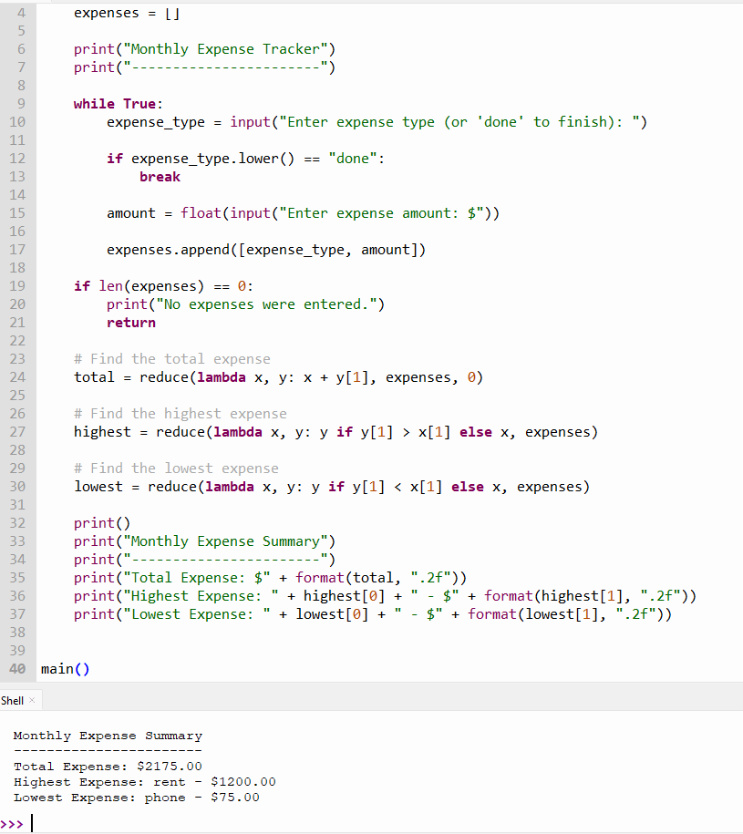
https://github.com/slade963/COP2373

